UNIVERSITY OF LJUBLJANA TO HOST ITS FIRST, VIRTUAL WESTERN BALKANS WORKSHOP

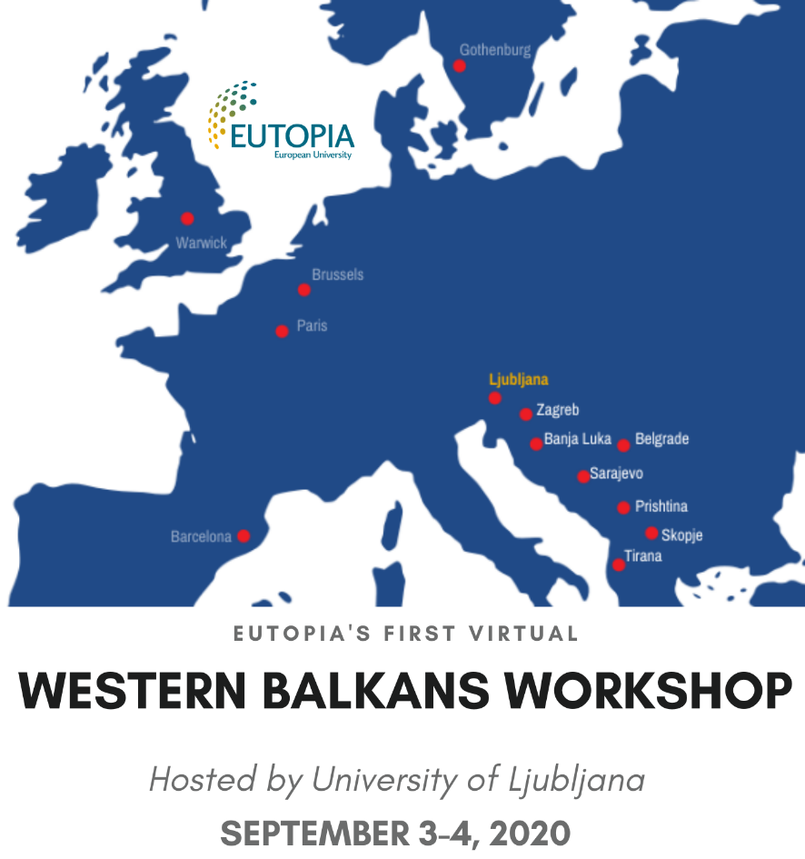

Next week, September 3-4, EUTOPIA2050 project's work package 5, Promoting inclusion and equal societies, is hosting its first virtual Western Balkans workshop, organized by University of Ljubljana. Students, teachers and administrative staff from many countries - Croatia, Bosnia and Herzegovina, Macedonia, Serbia, Kosovo, and Albania - will have the opportunity to take part in the workshop and learn from EUTOPIA partners about the international funding opportunities and development of institutional support services. Topics such as Structure and specifics of the new Horizon Europe, ERC, brain circulation and innovation gap, involvement of PhD and post-doc students in the research work will be presented and later discussed among participants.

University of Ljubljana takes pride in its long-lasting regional partnerships with Western Balkans universities, and is especially honored to have the opportunity to strengthen these partnerships through EUTOPIA2050 project, as well as share new experiences, encourage transfer of knowledge and bring regional relationships to a higher level.

Registration for the event is available through this link.
The overview of the programme is available here, where you can also find the links to each of the events.

We hope to see you there!

